Streamlining IT Procurement: Automating Standard Laptop Orders With Flow Designer
Project Description:
This project automates the ordering of standard laptops inside ServiceNow. Employees order a Standard Laptop (Lenovo Carbon x1) from the Service Catalog, and a Flow Designer flow named "Standard laptop tasks" runs automatically as soon as the order is placed. The flow creates a catalog task for the Hardware group, so the IT team receives the work without anyone raising it by hand.
The solution is built entirely by configuration on a ServiceNow Personal Developer Instance. It uses the Service Catalog for ordering, Flow Designer (Workflow Studio) for the automation, and the platform's Request, Requested Item and Catalog Task records for tracking. Because the flow is low-code, it is easy to read, easy to change and easy to extend later with manager approval, notifications and reports.
Scenarios
Scenario 1: A new employee needs a laptop. They open the Service Catalog, go to Hardware, select Standard Laptop, tick Adobe Acrobat as optional software and click Order Now. They see a confirmation with a request number, and the flow immediately creates a catalog task for the Hardware team.
Scenario 2: A Hardware team member opens the catalog task "Laptop need to Configured" that was created for the order. They configure the laptop and close the task, which completes the request.
Scenario 3: An administrator wants to change how orders are handled, for example the assignment group or the task description. They open the flow in Workflow Studio, edit the Create Catalog Task action and activate the flow again, without writing any code.
Technical Architecture:
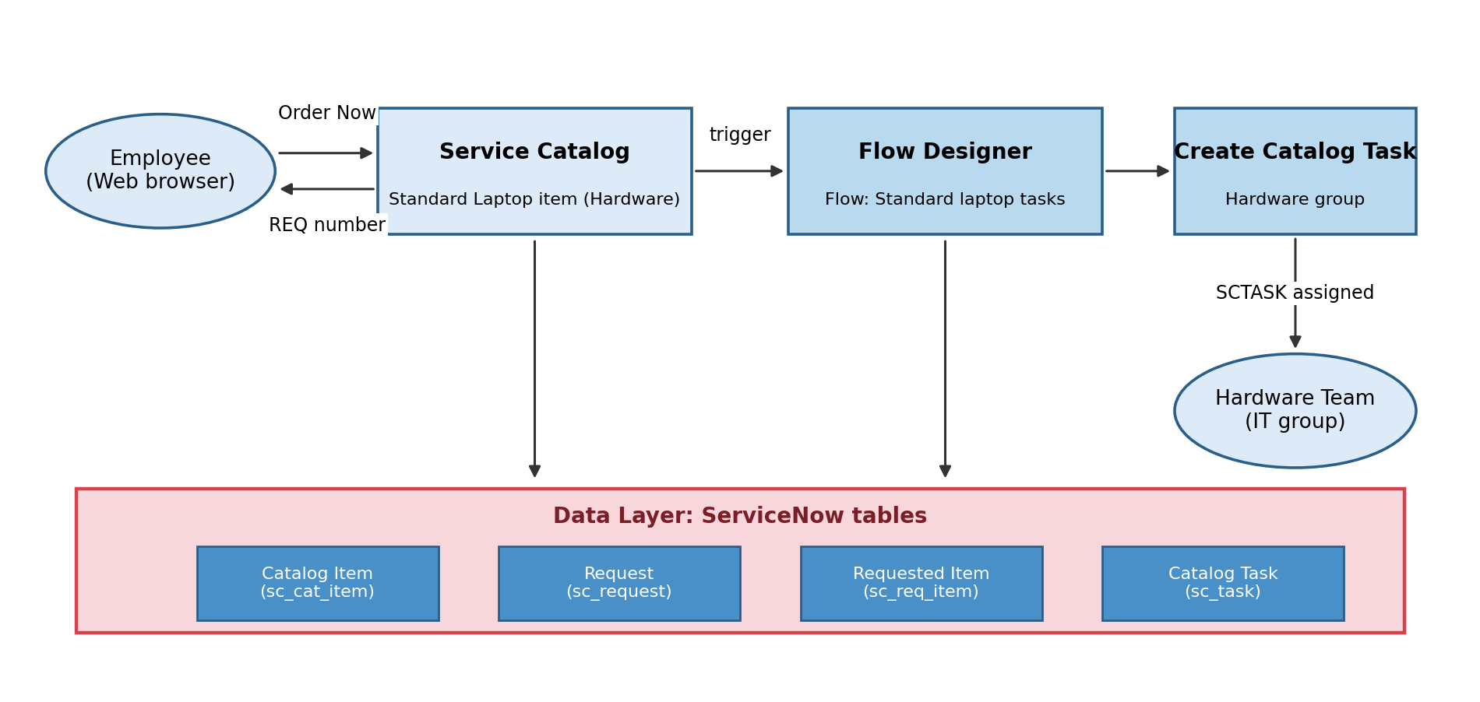
Figure 1: Technical architecture of the laptop ordering solution
Description: The solution follows a simple layered design. The employee uses a web browser to open the ServiceNow Service Catalog and order the Standard Laptop item. The order creates a request and a requested item and fires the Service Catalog trigger of the Flow Designer flow. The flow runs the Create Catalog Task action, which creates a catalog task for the Hardware group. All records are stored in the ServiceNow tables.
Data relationships (ER diagram): The solution uses ServiceNow's built-in tables. A catalog item is ordered through a request, each request holds one or more requested items, and each requested item has one or more catalog tasks.
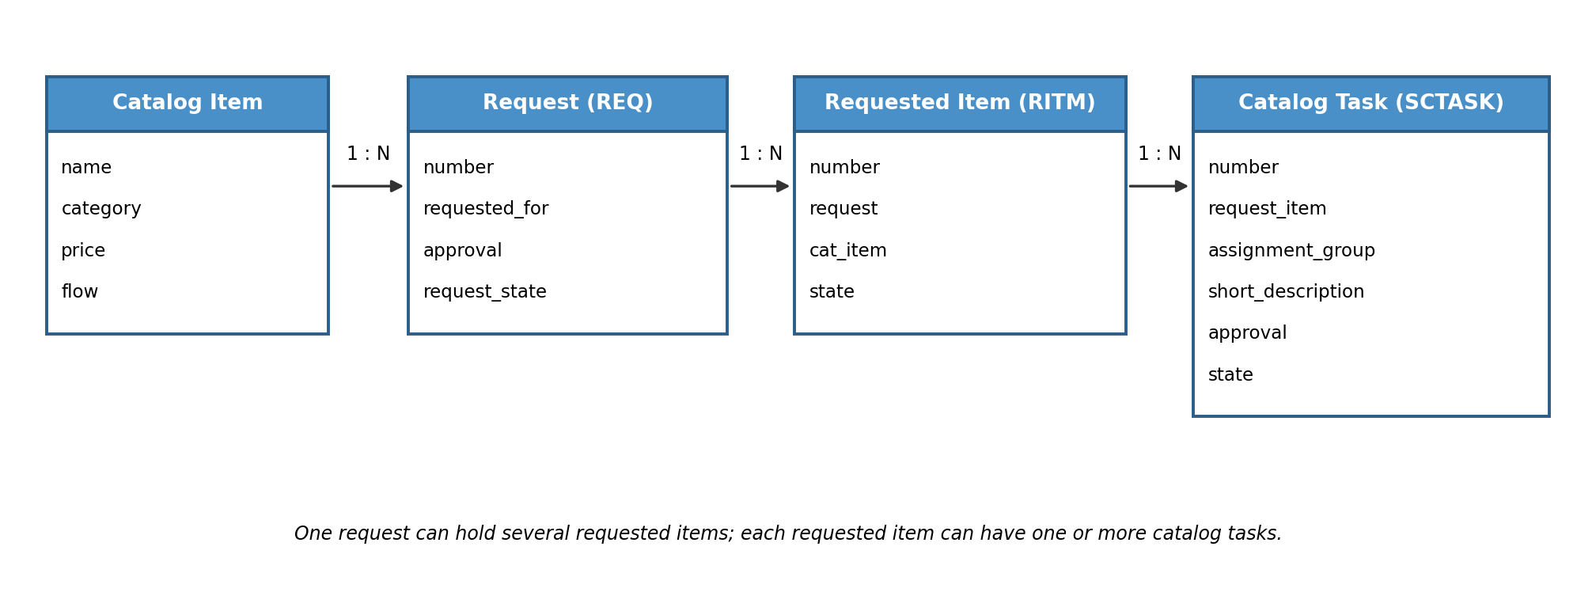
Figure 2: Relationship between the ServiceNow tables used
Pre-requisites:
- ServiceNow Personal Developer Instance: a free instance from the ServiceNow Developer Program (dev363503).
- Service Catalog Knowledge: understanding of catalog items, categories and variables.
- Flow Designer Familiarity: understanding of triggers, actions and how to activate a flow.
- Request Management Basics: knowing what a Request (REQ), Requested Item (RITM) and Catalog Task (SCTASK) are.
- Web Browser: a current version of Chrome or Edge.
- Version Control with GitHub: to store the project documents and screenshots.
Project Workflow:
Milestone 1: Catalog Item Setup
- Activity 1.1: Open the Service Catalog and explore its categories.
- Activity 1.2: Open Maintain Items and locate the Standard Laptop catalog item.
- Activity 1.3: Review the catalog item details, category, price and variables.
Milestone 2: Flow Creation
- Activity 2.1: Open Flow Designer (Workflow Studio).
- Activity 2.2: Create a new flow named "Standard laptop tasks".
- Activity 2.3: Add the Service Catalog trigger.
Milestone 3: Flow Actions and Activation
- Activity 3.1: Add and configure the Create Catalog Task action.
- Activity 3.2: Activate the flow.
Milestone 4: Linking the Flow to the Catalog Item
- Activity 4.1: Select the flow on the Process Engine tab of the catalog item and update it.
Milestone 5: Testing the Solution
- Activity 5.1: Order the Standard Laptop and check the request, requested item and catalog task.
Milestone 6: Conclusion
Milestone 1: Catalog Item Setup
In this milestone we open the ServiceNow Service Catalog and locate the Standard Laptop catalog item that employees will order. This confirms that the item exists, belongs to the Hardware category and is ready to be connected to a flow.
Activity 1.1: Open the Service Catalog
- Step 1 — Find the Service Catalog: In the ServiceNow application navigator, click All and type "service" in the filter. Under Self-Service, click Service Catalog.
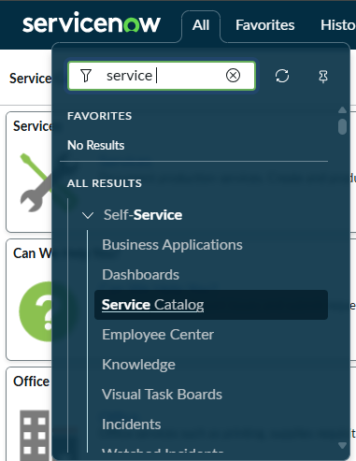
Figure 3: Searching for Service Catalog in the All menu
- Step 2 — Explore the categories: The Service Catalog home page shows the available categories such as Hardware, Software, Desktops, Office, Peripherals and Mobiles. The Top Requests panel on the right already lists Standard Laptop.
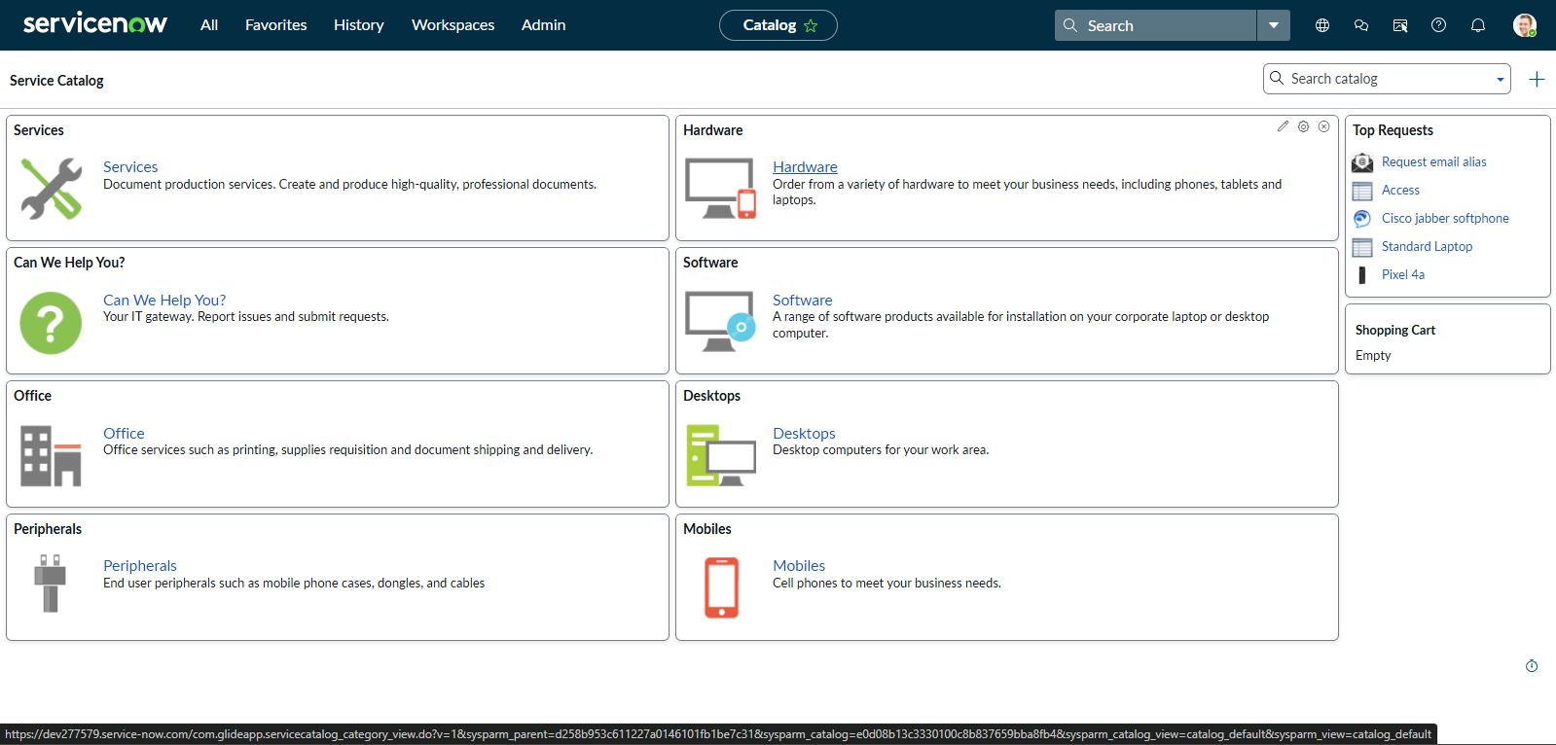
Figure 4: Service Catalog home page
Activity 1.2: Locate the Standard Laptop Catalog Item
- Step 1 — Open Maintain Items: Click All, type "Maintain Items" and open Service Catalog > Catalog Definitions > Maintain Items.
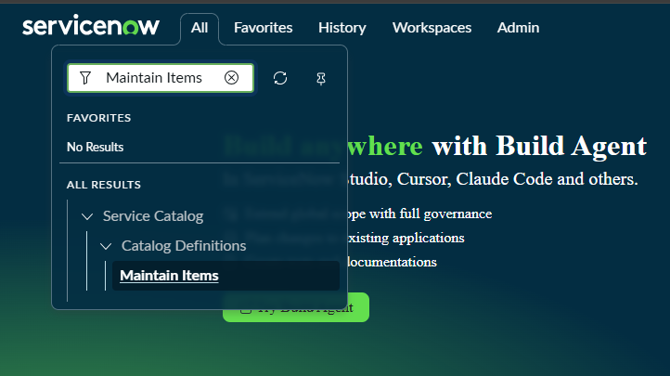
Figure 5: Opening Maintain Items from the All menu
- Step 2 — Search for the item: In the Catalog Items list, choose Name in the search field and type "Standard Laptop".
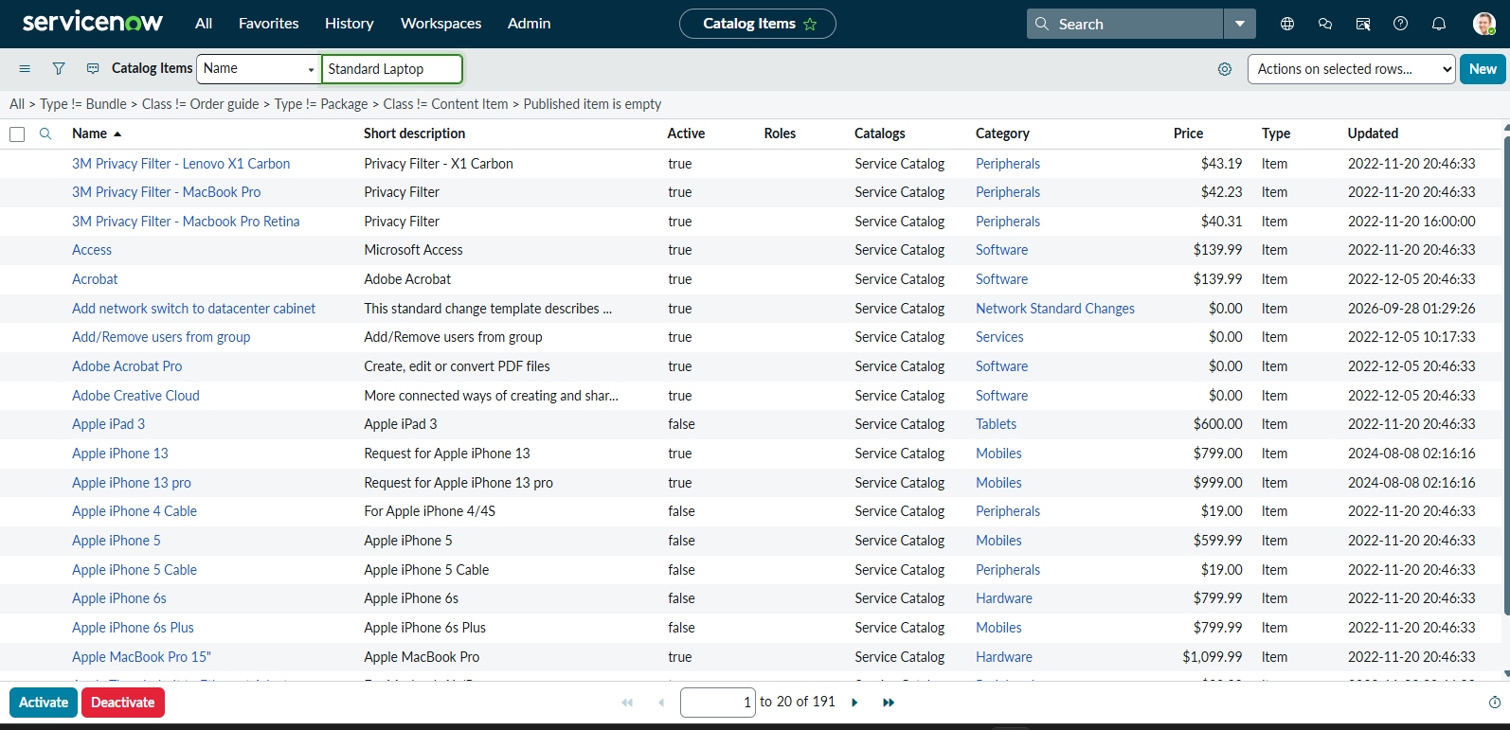
Figure 6: Searching the Catalog Items list
- Step 3 — Open the item: The list is filtered and the Standard Laptop item (Lenovo - Carbon x1, Hardware, $1,100.00) appears at the top. Click it to open the catalog item form.
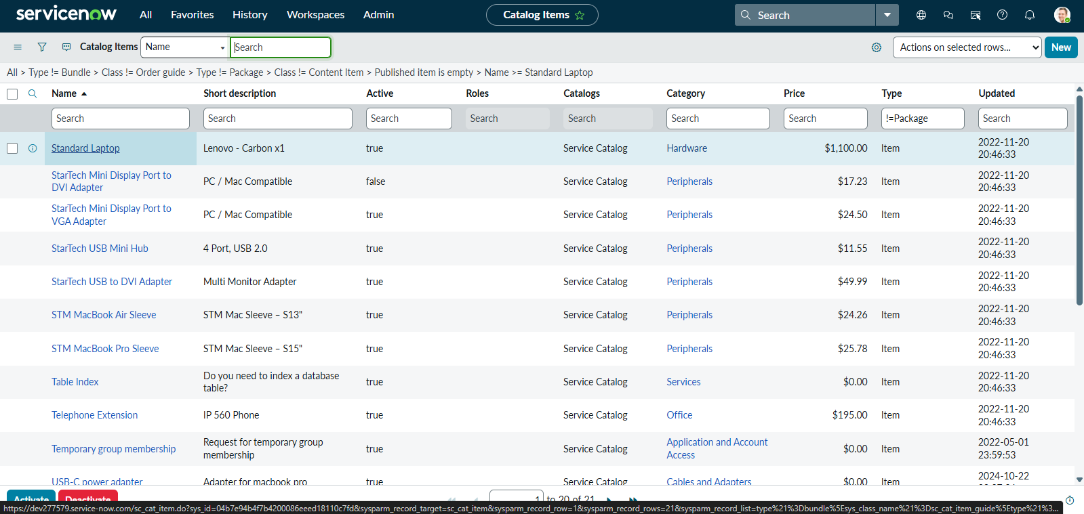
Figure 7: Standard Laptop found in the Catalog Items list
Activity 1.3: Review the Catalog Item
The catalog item form shows the Name (Standard Laptop), the catalog (Service Catalog), the category (Hardware) and the Active check box. Below the form, the Process Engine tab is where a flow can be attached to the item. At this point the item uses the default flow "Service Catalog item request". The Variables tab lists the optional software check boxes and the additional software requirements field.
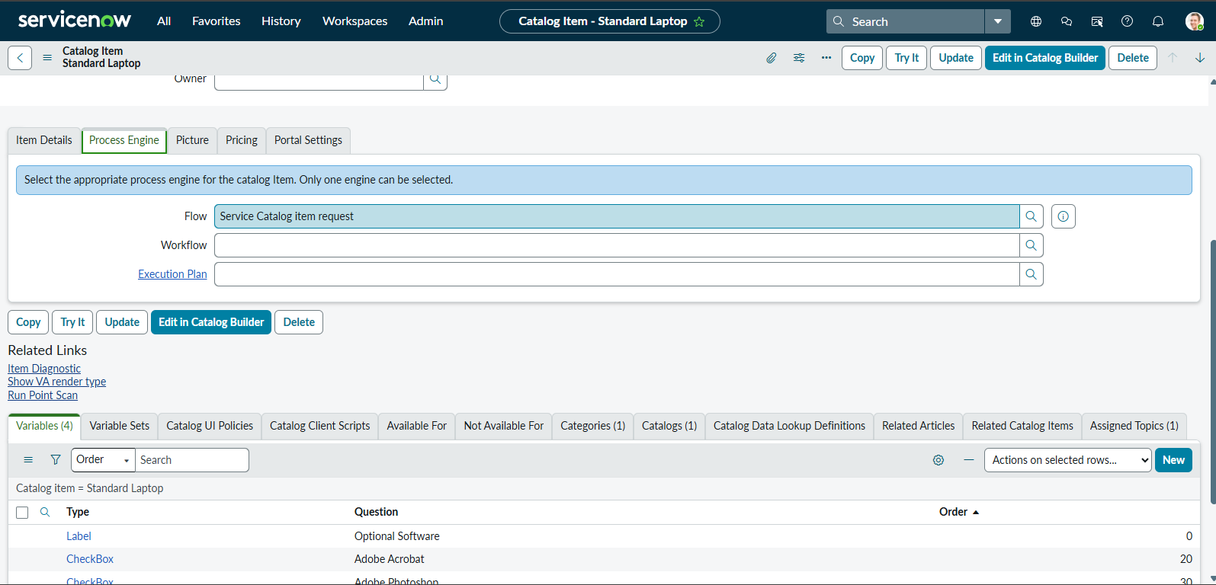
Figure 8: Catalog item with the default flow before linking
Milestone 2: Flow Creation
In this milestone we create the Flow Designer flow that will run every time the Standard Laptop is ordered.
Activity 2.1: Open Flow Designer
- Step 1 — Open Flow Designer: Click All, type "Flow Designer" and open Process Automation > Flow Designer. It opens in Workflow Studio.
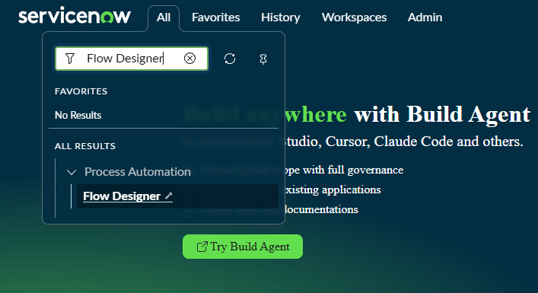
Figure 9: Opening Flow Designer from the All menu
- Step 2 — Workflow Studio home page: The Homepage lists the existing flows. Click New to create a new flow.
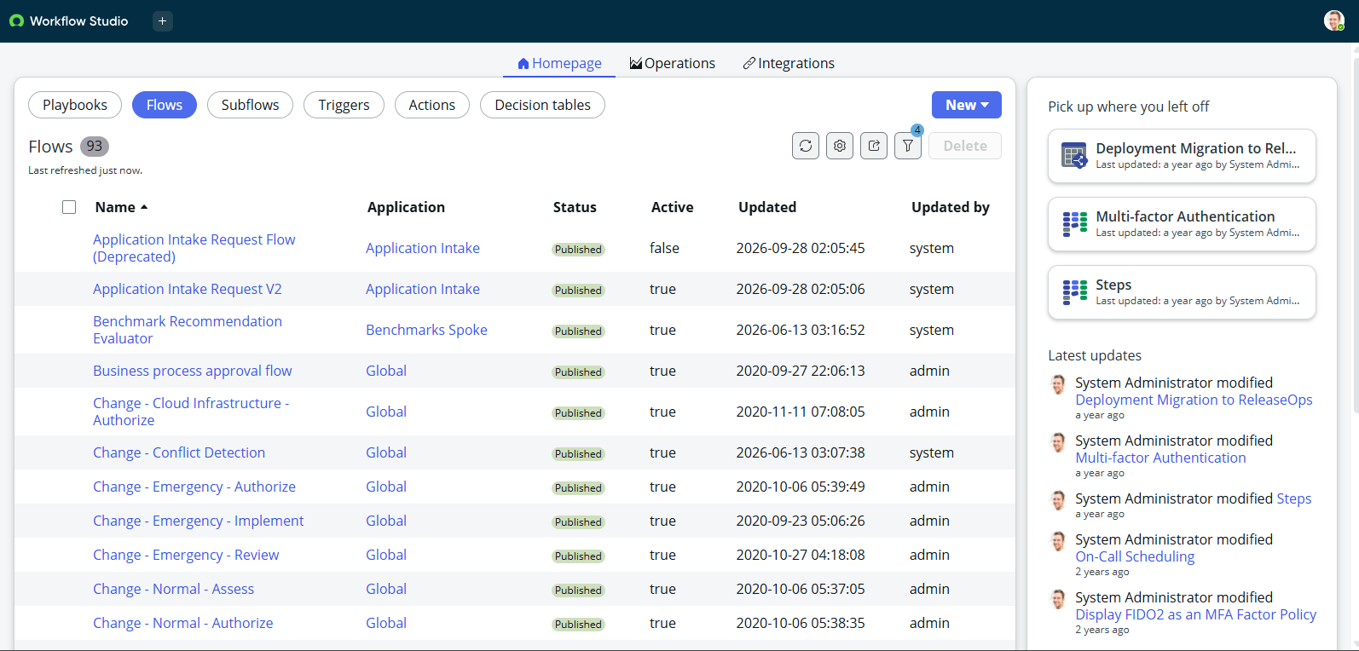
Figure 10: Workflow Studio home page with the list of flows
Activity 2.2: Create the Flow
- Step 1 — Enter the flow details: Type the Flow name "Standard laptop tasks", keep the Application as Global and click Build flow.
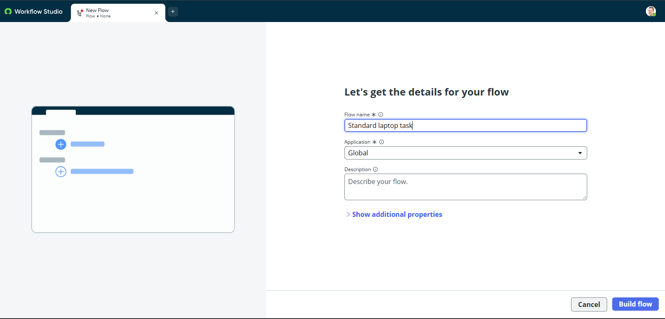
Figure 11: Creating the flow "Standard laptop tasks"
Activity 2.3: Add the Trigger
- Step 1 — Select the trigger: In the TRIGGER section choose Application > Service Catalog, so that the flow starts whenever a catalog item is ordered.
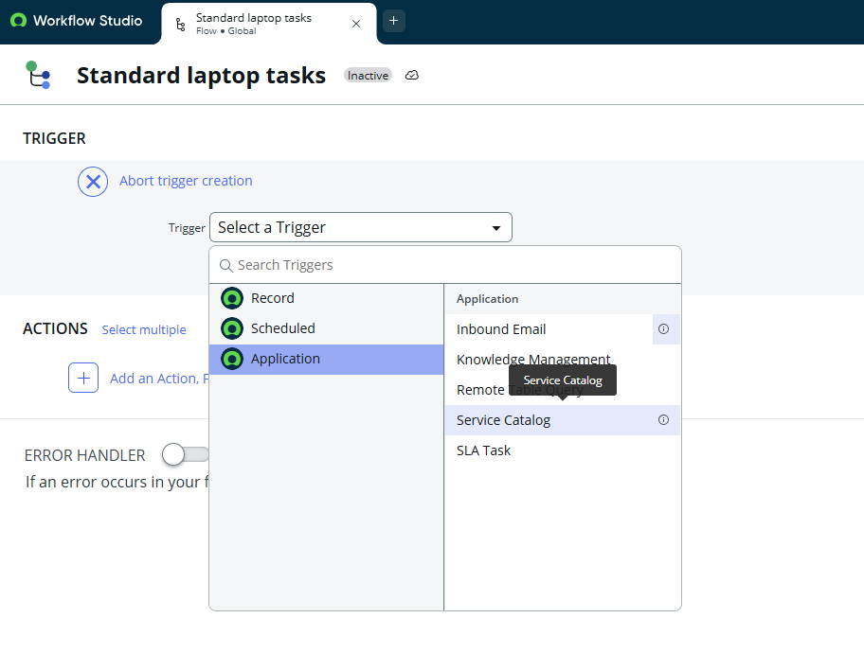
Figure 12: Selecting the Service Catalog trigger
Milestone 3: Flow Actions and Activation
In this milestone we add the action that creates the fulfillment task and then activate the flow.
Activity 3.1: Add the Create Catalog Task Action
- Step 1 — Add the action: Under ACTIONS click Add an Action, Flow Logic or Subflow and choose Create Catalog Task.
- Step 2 — Configure the action inputs: Table Name is Catalog Task [sc_task] and Requested Item is taken from the trigger (Requested Item Record). Set the Short Description to "Laptop need to Configured". In Fields add Description ("Laptop need to Configured"), Assignment group (Hardware) and Approval (Approved).
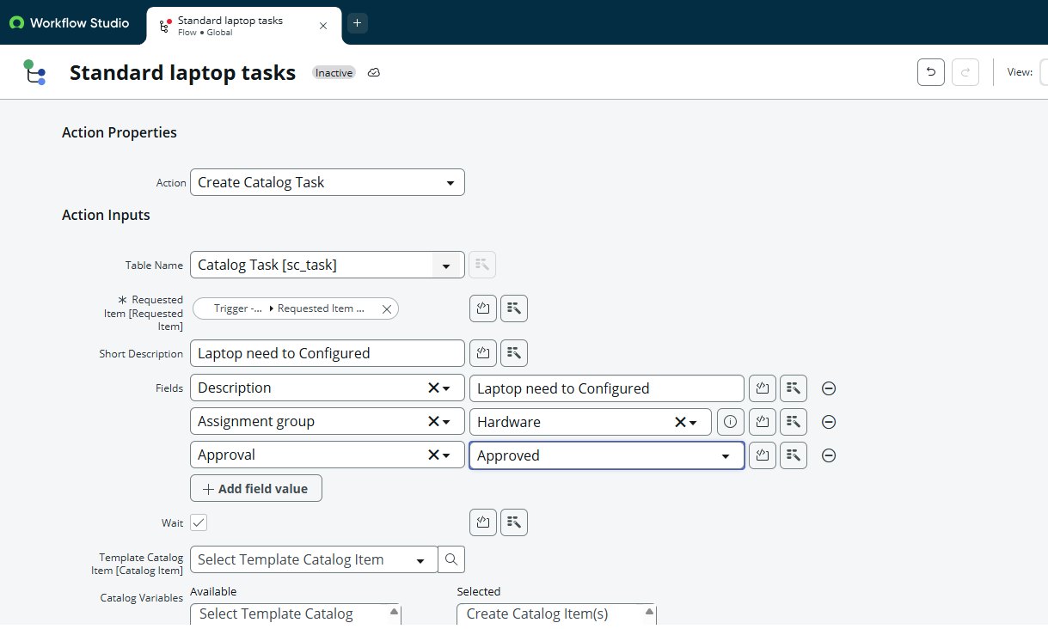
Figure 13: Configuring the Create Catalog Task action
- Step 3 — Review the flow: The flow now shows the Service Catalog trigger and one action, Create Catalog Task. The Data panel lists the Requested Item Record and the Catalog Task that the action produces.
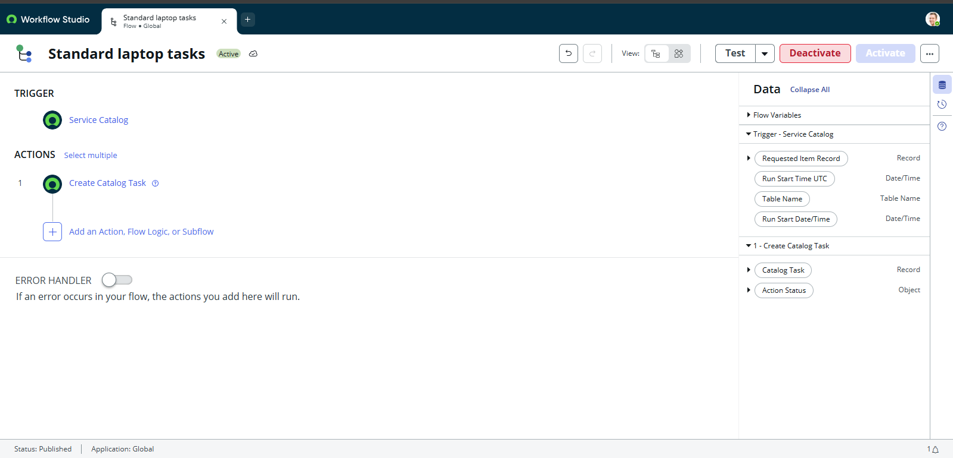
Figure 14: The flow with its trigger and action
Activity 3.2: Activate the Flow
- Step 1 — Activate: Click Activate. In the confirmation window click Activate again. The flow status changes to Active.
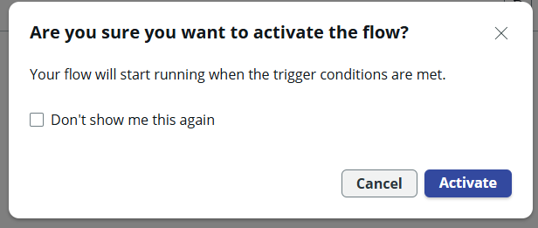
Figure 15: Activation confirmation
Milestone 4: Linking the Flow to the Catalog Item
The flow must be attached to the catalog item so that it runs when the item is ordered.
Activity 4.1: Set the Flow on the Process Engine Tab
- Step 1 — Open the Process Engine tab: Open the Standard Laptop item and click the Process Engine tab.
- Step 2 — Select the flow: In the Flow field search for and select "Standard laptop tasks". The Workflow and Execution Plan fields stay empty because only one engine can be selected.
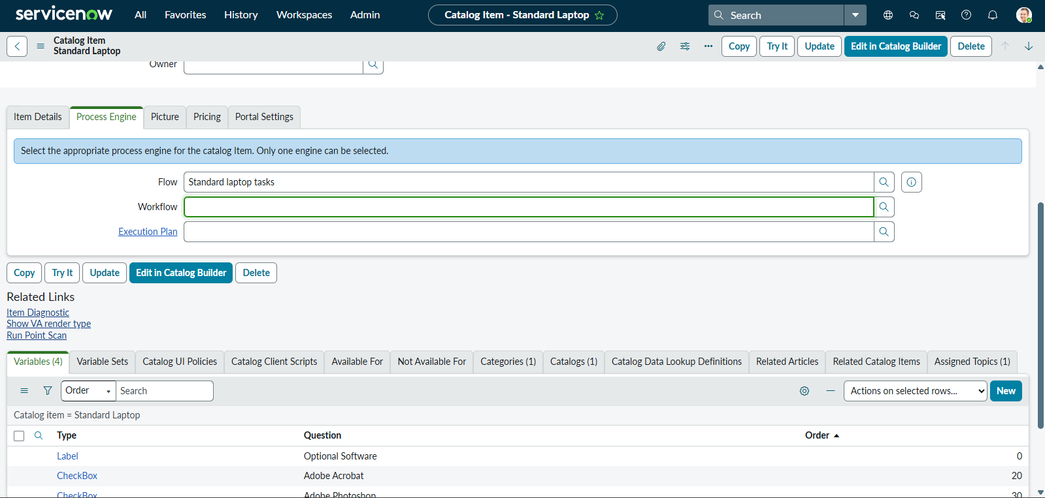
Figure 16: Flow set to "Standard laptop tasks" on the Process Engine tab
- Step 3 — Save the change: Click the menu (three lines) in the form header and choose Save, or click the Update button.
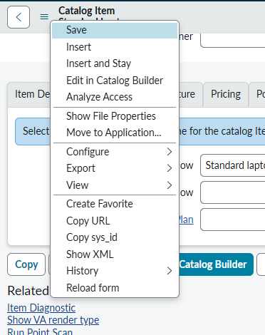
Figure 17: Saving the catalog item from the form menu
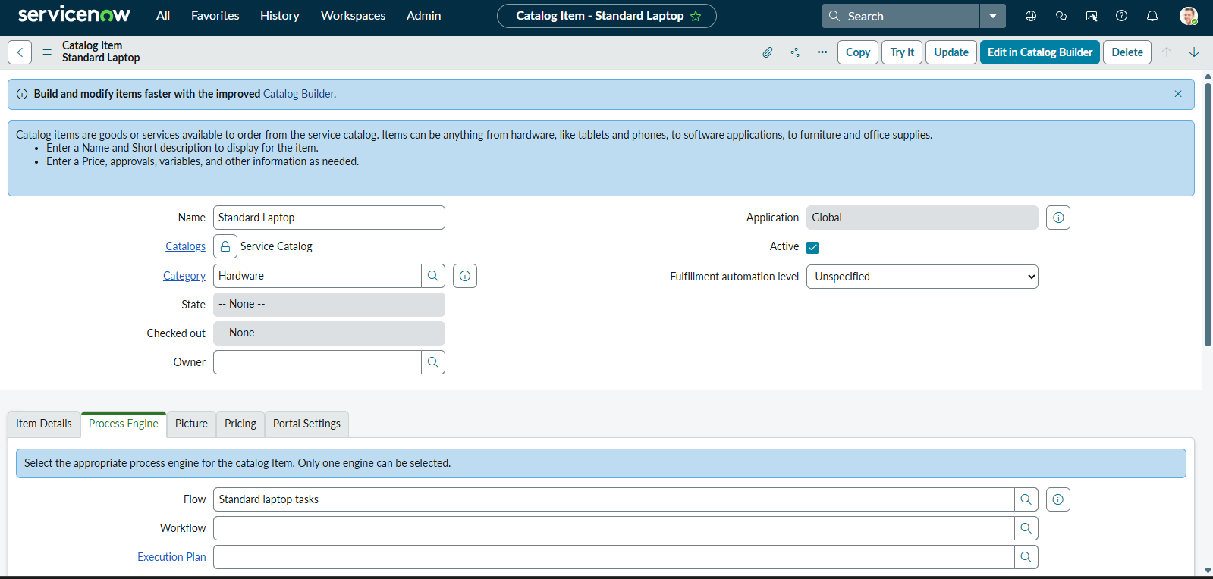
Figure 18: Catalog item form after the flow was linked
Milestone 5: Testing the Solution
In this milestone we order the laptop as an employee and check that the flow creates the expected records.
Activity 5.1: Order the Standard Laptop
- Step 1 — Open the item: Open Service Catalog > Hardware > Standard Laptop. The page shows the laptop description, technical specifications, the optional software check boxes (Adobe Acrobat and Adobe Photoshop), the additional software requirements field and the Order this Item panel with the price.
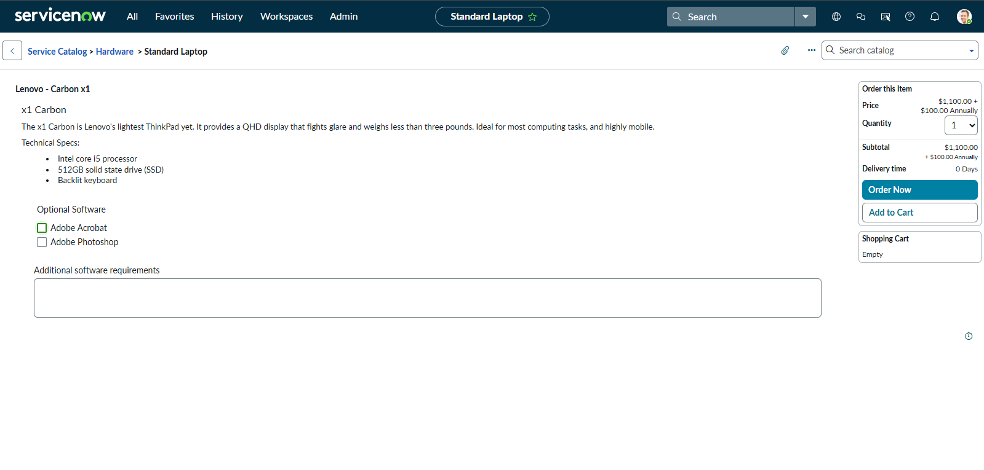
Figure 19: Standard Laptop catalog item page
- Step 2 — Place the order: Click Order Now. The Order Status page confirms "Thank you, your request has been submitted" and shows the request number REQ0010001.
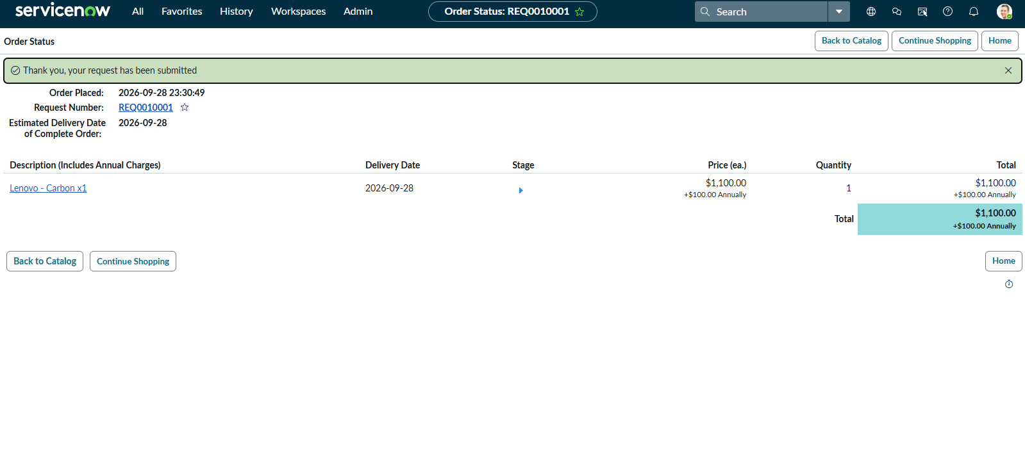
Figure 20: Order Status page with the request number
Activity 5.2: Verify the Request and the Catalog Task
- Step 1 — Check the request: Open REQ0010001. It shows the requester, the opened time, the price ($1,100.00), Approval as Requested and Request state as Pending Approval.
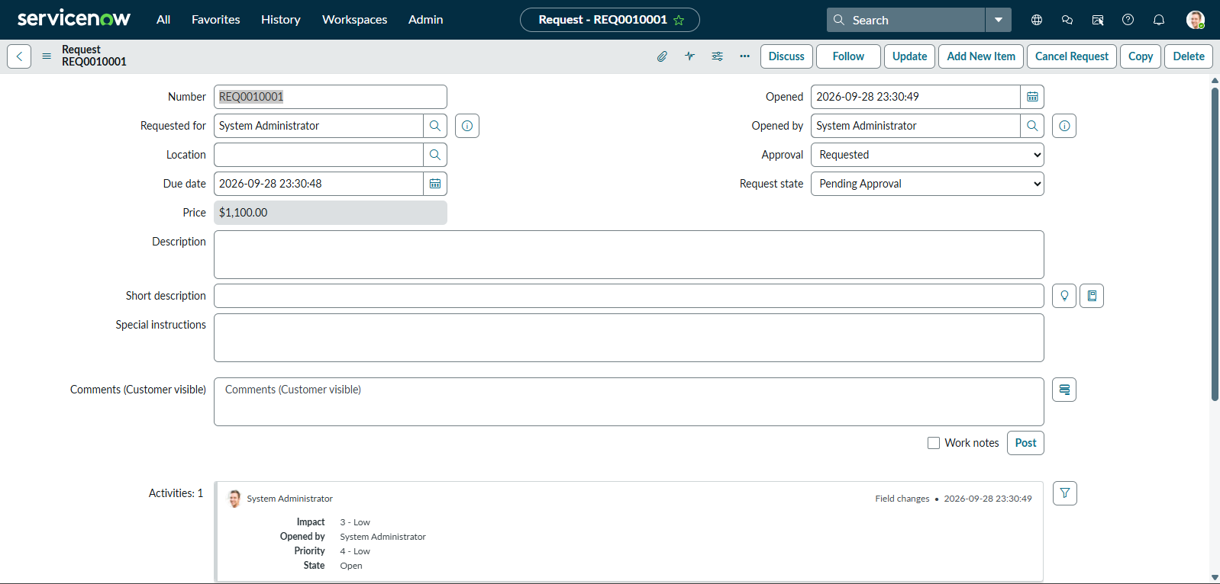
Figure 21: Request REQ0010001
- Step 2 — Check the catalog task: The flow created the catalog task SCTASK0010001 for the requested item RITM0010001. Its short description and description are "Laptop need to Configured", Approval is Approved and State is Open. The task was created about 82 seconds after the order.
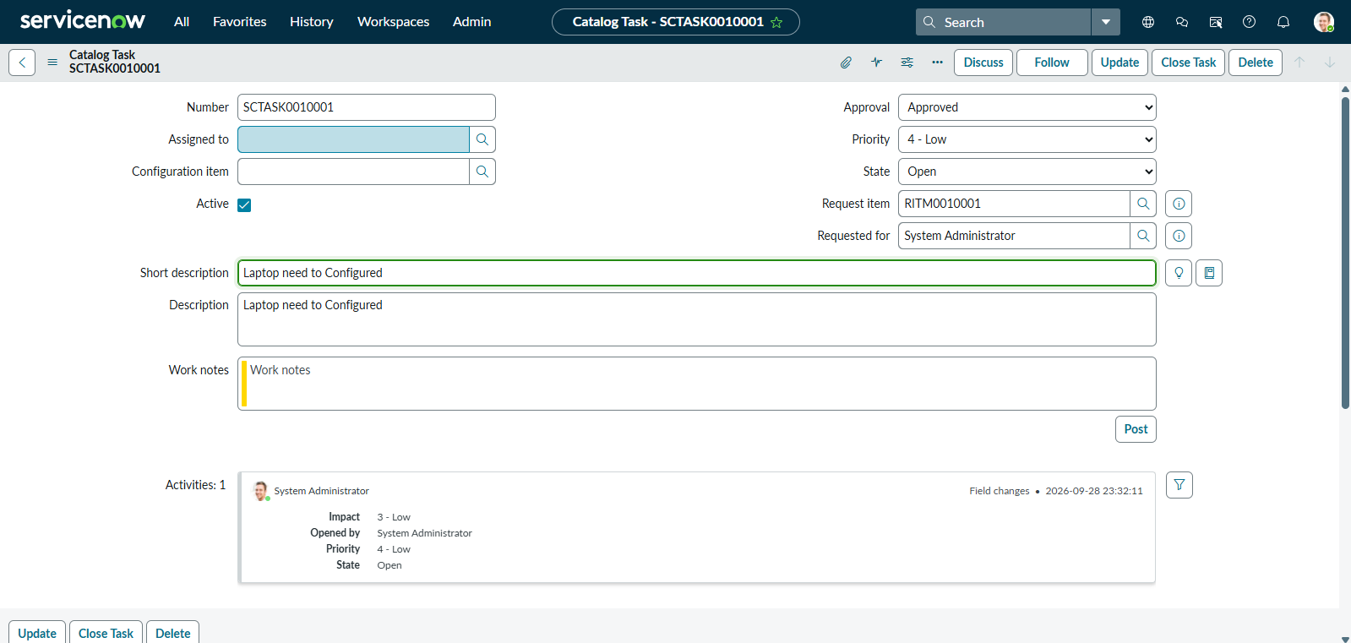
Figure 22: Catalog task SCTASK0010001 created by the flow
Exploring the Solution's Pages:
Service Catalog Home Page:
Description: The entry point for employees. It shows the catalog categories and a Top Requests panel that includes Standard Laptop, with a shopping cart on the right.
Standard Laptop Item Page:
Description: Shows the laptop details, the optional software check boxes, an additional requirements box and the Order Now and Add to Cart buttons with the price.
Order Status Page:
Description: Confirms that the request was submitted and shows the request number, the time of the order, the estimated delivery date and the price.
Request and Catalog Task Records:
Description: The request record shows the state of the whole order. The catalog task record is the work item for the Hardware group and is linked to the requested item.
Conclusion:
This project shows how ServiceNow Flow Designer can automate a routine IT procurement step. By ordering a Standard Laptop through the Service Catalog, a request is created and the flow "Standard laptop tasks" automatically creates a catalog task for the Hardware group, so no one has to raise the task manually. The solution was built without any code, tested with a real order (REQ0010001 and SCTASK0010001) and worked without errors.
Looking ahead, the flow can be extended with a manager approval step, email notifications to the requester, asset and inventory updates and a dashboard for order status and delivery time. Adding an error handler and a flow description would also make the solution easier to maintain.

